HTML 5 & JavaScript: Campsite Booking Application.

Project Team.

**B00278705**

**B00291618**

The Application.

We developed an online campsite booking application, this app would allow the user to select different types of accommodation , choose their arrival and departure dates, select how many adults and children would be in the party, The app will calculate the cost of the stay by taking the price of the accommodation and multiplying it by the number of nights they are staying for, it will then allow the user to enter their full name, address, postcode, telephone number and email address.

The app also allows the user to view photos of the campsite, view and retrieve previous bookings they have made, and cancel a booking if required. It also features a section that will allow the user to select from a list of local activities and display their location on a google map, finally there is a feature that will allow the user to leave a comment and also view comments previously left by other holiday makers.

Please Note this application is is optimised for google chrome and is our recommemded browser.

Design Changes.

The original design was basic and cluttered and we felt that a few changes were necessary, The major changes were the introduction of panels this gave us the ability to include more content in the panels but hide them if they were not needed at the time, this reduced the cluttered look of the original, we then introduced a video background which give the site a modern and professional appearance, this did however cause some additional issues with regards to the text and how that appeared on top of the background, we overcame this by making the panels the text resides on opaque so that the video did not distract the user too much and the text was easily readable.

Variables and Types amendments.

Items Added:

* ******* WILL DO THIS LATER ********

Items Removed:

* ******* WILL DO THIS LATER ********

Testing.

We implemented several testing strategies to enable us to test the functionality, usability, and compatibility of the app. Testing was undertaken at various stages of the development and at key points in the life cycle of the app. The tests were introduced before we would proceed onto the next section with the exception of compatibility as this was left until the app was complete.

Functionality:

* Validation of date fields to ensure dates were after current date and departure date was after arrival date.
* Validation that at least 1 adult will be included in the party.
* Validation of telephone number was 11 digits long.
* Validation that email address entered was in the correct format.
* Correct booking displayed when selected.

Usability:

* All panels opened and closed correctly and displayed their correct content.
* All buttons operated in the correct manor.
* Price and number of nights updated as booking was changed.
* Number of adults and number of children updated when sliders moved.
* All photos displayed correctly.
* Video played correctly.
* Bookings displayed correctly and in the correct panel.
* Map updated when local activity selected.
* Text updated when local activity selected.
* Comments displayed correctly and in the correct panel.

Compatibility:

* Check all functions worked with Internet Explorer.
* Check all functions worked with Firefox.
* Check all functions worked with Safari.
* Check all functions worked with Google Chrome.

Test Data.

This is our final selection of the data used to test the application , as testing was a recursive cycle the data input during creation was very similar every time we tested a section. This data was used in the final testing to ensure the application was doing what was intended.

|  |  |  |
| --- | --- | --- |
| Item Tested | Data Input / Action Used | Result |
| Panels | Select panel header | All panels open and close |
| Accommodation List | Selected each item | Correctly displayed item |
| Arrival date & Departure date | Current date for both | Output correct |
| Arrival date & Departure date | Arrival before departure | Output correct |
| Arrival date & Departure date | Departure before arrival | Error message displayed |
| Arrival date & Departure date | Two random dates | Output correct |
| Pictures | Selected | Picture displayed |
| Number of adults | 1 > 5 / Slider | Output Correct |
| Number of adults | 0 | Error message displayed |
| Number of Children | 0 > 5 / Slider | Output Correct |
| Full Name | Various Names / Text | Entered data correclty |
| Full Name | No Text / Text left blank | Error message displayed |
| Address | Various address / Text | Entered data correclty |
| Address | No Text / Text left blank | Entered data correclty |
| Postcode | Various address / Text | Entered data correclty |
| Postcode | No Text / Text left blank | Entered data correclty |
| Telephone Number | No Text / Text left blank | Error message displayed |
| Telephone Number | 11 digits beginning with 01,02 or 07 | Entered data correclty |
| Telephone Number | < 11 and >11 digits | Error message displayed |
| Telephone Number | Various Text / Text | Error message displayed |
| Email Address | No Text / Text left blank | Error message displayed |
| Email Address | Various email addresses | Entered data correclty |
| Email Address | No '@' and no '.' | Error message displayed |
| Email Address | Various Text / Text | Error message displayed |
| Make Booking Function | Completed Form | Table of booking displayed |
| Make Booking Function | Duplicate booking | Error message displayed |
| Clear Booking | Button Push | All Fields cleared, dates reset, sliders reset. |
| Cancel Booking | Button Push | Message displayed, booking removed from table |
| Edit Booking | Button Push | Message displayed, booking removed from table and from filled with correct data |
| Local Activities list | Selected each item | Displayed correct image and text |
| Comment Text | Varoious Text / Text | Entered data correctly |
| Comment Text | No Text / Text left blank | Error message displayed |
| Comment Button | Button push | Table of comments displayed. |

Test Results.

The tests were completed in stages, only when these were fixed would we proceed.

Stage one: Cost did not update.

Arrival Date allowed before departure date if accommodation changed.

Telephone number validation fail.

Number of adults not validated.

Map did not display correctly.

Local activities panel would not close.

Booking data displayed incorrectly.

Text displayed in wrong font.

Photos displayed in the wrong location.

Stage two: Could not select correct booking.

Email not sending after booking.

Price displayed as NaN if input data was invalid.

Number of nights displayed as NaN if input data was invalid.

Panel headings would not change when selected.

Stage 3: Most bugs removed and all test data passed.

Bugs still not fixed due to time restraints

* Total cost sometimes displays minus figure if data not entered in order, but displays correctly when form completed
* Images sometimes display incorrectly if browser is resized.
* Firefox not displaying table or map correctly.
* Firefox dates need entering manually
* Page does not move when panels are opened the user must scroll page down.

Screen Shots.

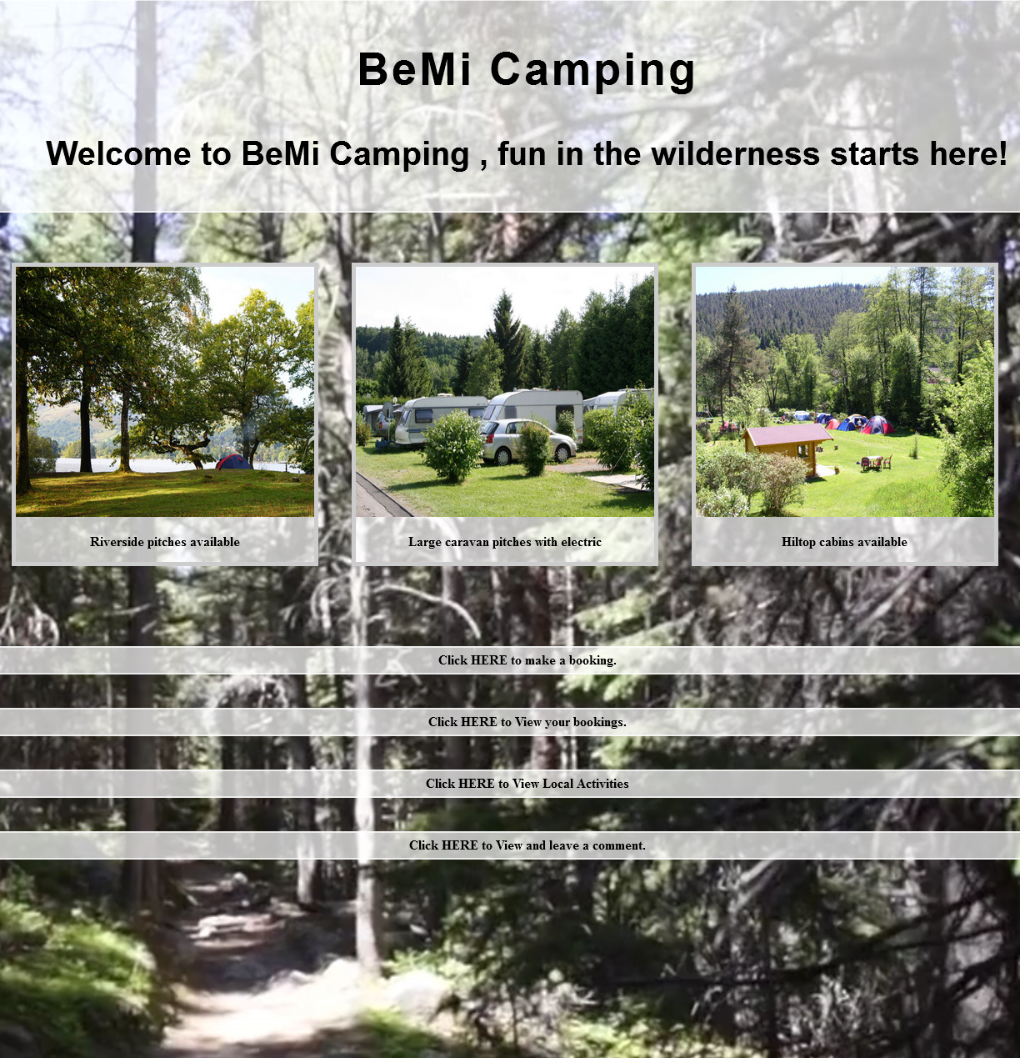

Team Work.

Both of us fulfilled the roles that were required of us in a timely and professional manner, we had weekly meetings and had plenty of contact over email, we worked closely together through all stages of the development of this app, we helped each other in the areas of programming that were difficult and we both give 100% to the development of this web app, we both feel we have learned a lot from working in a team as we come from different backgrounds and are of different age groups, we feel this has developed our team skills enormously as this is how it would be in the workplace.

Minutes

The folowing minutes are from meetings that we had after sumitting stage one of this project.

**Meeting Number:** 9

**Date:** 09/11/2016

**Attendees:** Michael Robinson, Rebekah Young

**Minute Taker:** Rebekah Young

**Discussion**

After submitting Part 1 of our project we looked at the specification for the second submission and discussed our next steps. We looked at what we would improve on in terms of usability, design and functionality. We agreed that testing the application regularly would be beneficisl as it would flag up any issues with coding.

**Result**

We identified tasks and decided who would take on each one.

|  |  |  |  |
| --- | --- | --- | --- |
| **Action** | **Discussion** | **Result** | **Person Responsible** |
| Add to current HTML file | adapt and improve HTML file to allow for dynamic javascript to be added to application. Send to Michael once completed. | To complete | Rebekah |
| Create Javascript file | once HTML received, create javascript to add function to current application | To complete | Michael |
| Application Testing | application should be tested regularly to check on the functionality and usability. | On going | Michael/Rebekah |

**Meeting Number:** 10

**Date:** 16/11/2016

**Attendees:** Michael Robinson, Rebekah Young

**Minute Taker:** Michael Robinson

**Discussion**

We discussed our progress with tasks allocated at previous meeting and looked at the overall design of the application. The design was basic and cluttered and this was something we would need to improve on. Michael suggested that a video element be added to the webpage and be used as a background.

**Result**

Decided to implement some css and improve on HTML to allow for further javascript development. look for appropriate video file to add to background and add in to application.

|  |  |  |  |
| --- | --- | --- | --- |
| **Action** | **Discussion** | **Result** | **Person Responsible** |
| Add to current HTML file | adapt and improve HTML file to allow for dynamic javascript to be added to application. | On going | Rebekah |
| Create Javascript file | create javascript to add function to current application | On going | Michael/Rebekah |
| Application Testing | application should be tested regularly to check on the functionality and usability. | On going | Michael/Rebekah |
| Implement css | add css to create a more aesthetically pleasing and sleek application | To complete | Rebekah |
| Add video file | find appropriate video file and add to HTML file as background | To complete | Michael |

**Meeting Number:** 11

**Date:** 23/11/2016

**Attendees:** Michael Robinson, Rebekah Young

**Minute Taker:** Rebekah Young

**Discussion**

After adding the video file background the text within the application became illegible. This was something we would need to work on as we felt that the video background was a good addition to the overall look of the application. Throughout the testing we found that some of the elements within the application were not working as we expected.

**Result**

Work on css to allow text and content of application to be more visible. look over all coding to figure out why certain elements were not working properly.

.

|  |  |  |  |
| --- | --- | --- | --- |
| **Action** | **Discussion** | **Result** | **Person Responsible** |
| Add to current HTML file | adapt and improve HTML file to allow for dynamic javascript to be added to application. | On going | Rebekah |
| Create Javascript file | create javascript to add function to current application | On going | Michael/Rebekah |
| Application Testing | application should be tested regularly to check on the functionality and usability. | On going | Michael/Rebekah |
| Check over all coding | check over all coding, both HTML and Javascript, and amend where necessary to ensure that elements work properly. | To complete | Michael |
| Add to css | add further css to improve on usability | To complete | Michael/Rebekah |

**Meeting Number:** 12

**Date:** 30/11/2016

**Attendees:** Michael Robinson, Rebekah Young

**Minute Taker:** Michael Robinson

**Discussion**

Both HTML and Javascript files were completed. Final testing would need to be done. We discussed the final documentation for the application and both brought any previous documentation we already had.

**Result**

.Final testing of application to be carried out to ensure that all aspects and elements were working as expected. individual documentation would need to be brought together into one final group document to be submitted with application code.

|  |  |  |  |
| --- | --- | --- | --- |
| **Action** | **Discussion** | **Result** | **Person Responsible** |
| Add to current HTML file | adapt and improve HTML file to allow for dynamic javascript to be added to application. | Completed | Rebekah |
| Create Javascript file | create javascript to add function to current application | Completed | Michael/Rebekah |
| Application Testing | application should be tested regularly to check on the functionality and usability. | Completed | Michael/Rebekah |
| Check over all coding | check over all coding, both HTML and Javascript, and amend where necessary to ensure that elements work properly. | Completed | Michael |
| Add to css | add further css to improve on usability | Completed | Rebekah |
| Final Tests | carry out final testing of application and ensure all elements working before submitting. | Complete and submit | Michael |
| Final documentation | Create final document to be submitted along with application code. | Complete and submit | Michael/Rebekah |